Van Pelt, John (from Linked In)
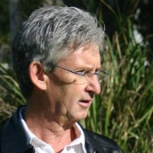

Bachelor of Science (B.Sc.) Forestry ANU 1964 – 1967, Grad Dip Landscape Architecture University of NSW 1974 – 1975.
Landscape architect that specializes in landscape and visual impact assessment.
He has 30 years experience in the assessment of infrastructure and development projects in both rural and urban settings. He has worked for a range of private and government clients in Qld, NSW, Vic, SA and WA as well as worked in Indonesia and Philippines.

Field Forester Forestry Commission NSW 1970 –1973, Queanbeyan & Kyogle NSW. Recreation and Landscape Planning Officer Forestry Commission of NSW 1973 –1977, Sydney. Lecturer Canberra College of Advanced Education (now University of Canberra) 1977 –1983 Canberra. Director Forsite Landscape Architects & Planners 1984 –1989, Sydney. Director in charge of environmental, landscape and visual planning & Design. Principal EDAW (Aust) Pty Ltd 1989 –2002. Principal in charge of landscape and visual impact assessment. Managing Principal jvp visual planning & design 2002 – , Brisbane. Practice focused on landscape and visual assessment and impact evaluation and mitigation.

